Indian Institute of Technology, Kharagpur
Department of Computer Science and Engineering
Model Answer
Object-Oriented Systems (CS60059)

Time=2 Hours Max Marks=80
Important Instructions:
- Answer all questions
- No clarification to any of the questions shall be provided during examination. In case you have any questions, you can make any suitable assumptions you feel is absolutely necessary, but please write down your assumptions clearly.
- All answers should be brief and concise. Lengthy and irrelevant answers will be penalized.

- Draw a UML class diagram corresponding to the following Java code. [5]
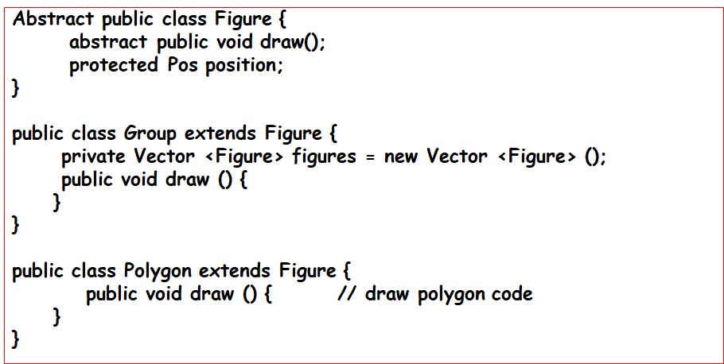
Ans:
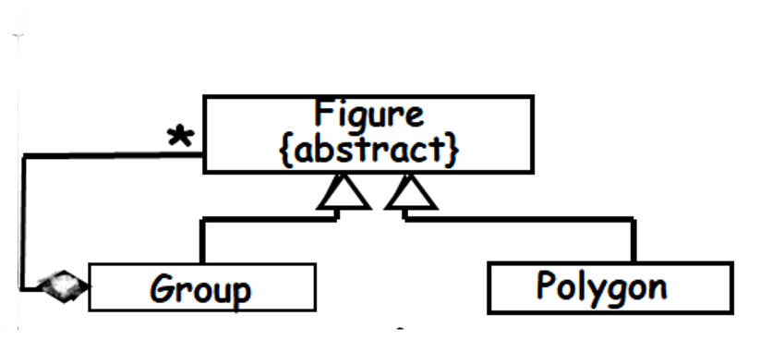
- Identify the relationship that exists between Professor and Course classes in the following UML class diagram. Suggest a possible reason as to why this relationship might arise between the two classes. For the reason that you identify, give Java code to illustrate the relation. [2+3]
Ans:
Relationship: Dependency ... Award 2 Marks
Course
Professor

class Professor {
1
public void teach() { Course c = new Course(); ……..}
……………..
}
class Professor {
2
public void teach(Course c) { ……..}
……………..
}

class Professor {
3
Course c;
public void teach(Course c) { ……..}
……………..
}
Any of 1,2,or 3: Award 3 Marks

- Develop a sequence diagram to model the object interactions implemented in the following Java code segment. You should make use of UML combined fragment wherever required. [5]
public class A{
B b = new B();
C c = new C();
public void doX(){
...
if (x < 10)
b.calculate();
else
c.calculate();
}
}

Ans:
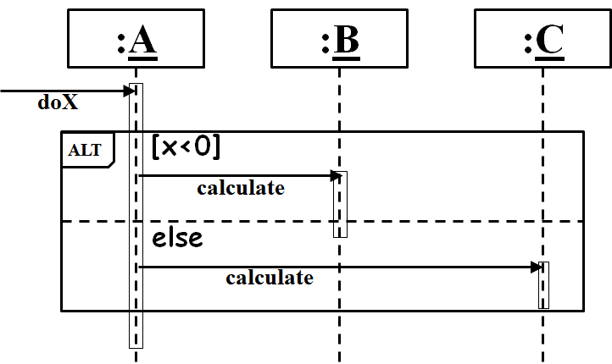
- Consider a software that is being developed to automate the clerical activities in a video rental system. In the design of the rent a video use case, the following interactions between the video store clerk and video objects are envisaged. Draw a sequence diagram to represent the object interactions in the rent a video use case. [5]
  - The store clerk creates a new Rental object named aRental. The create message includes the arguments memberID and videoID.
  - aRental sends addMemberToRental message to the Member object named aMember with the parameter memberID, which returns memberDetails.
  - aRental sends rentVideo message to a Video object named aVideo with the parameter videoID, which returns videoDetails.
  - aRental returns rentalDetails to the actor.
Ans:

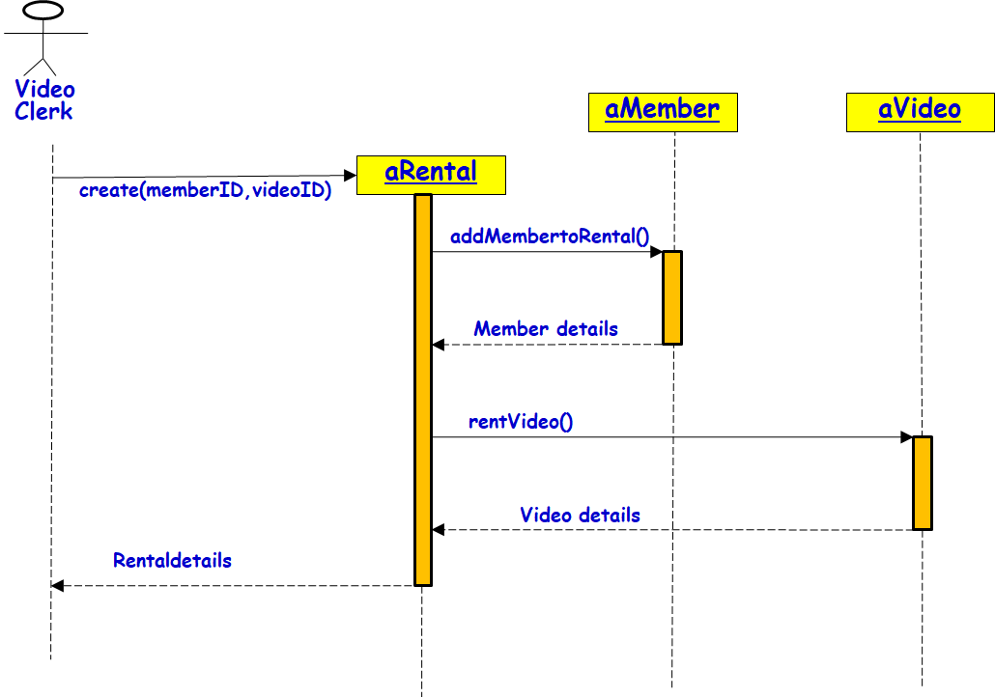
- Model the following partial behaviour of a chemical plant using a UML state machine diagram. [10]

In a chemical plant, several sensors have been placed to sample the plant parameters. The system checks these parameters for anomalies. Whenever any anomaly is detected, a recovery process is initiated and further uptake of reactants is stopped. During recovery, first the problem is diagnosed to be either at the temperature control or the process control subsystem. Depending on the diagnosis, the specific recovery (temperature or pressure) is initiated. Whenever successful recovery is indicated by the sampled sensor data, the plant would resume operation in the normal mode and uptake of reactants would be enabled. At any time, a recovery failure would shut down the system.
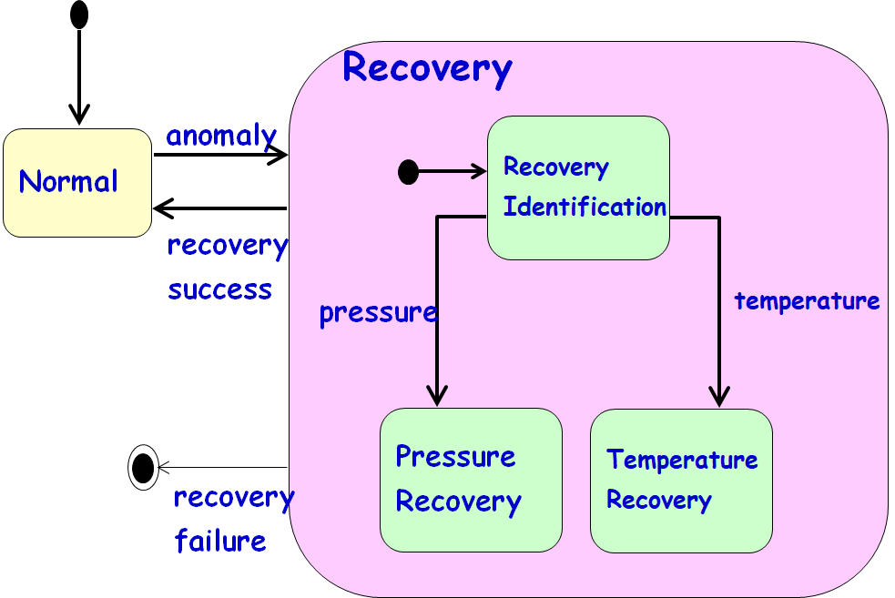

- Consider the following sequence diagram. Based on the given diagram, write skeletal Java code for the class AssgSubCmd. Limit your code to only what is conveyed by the diagram. [10]
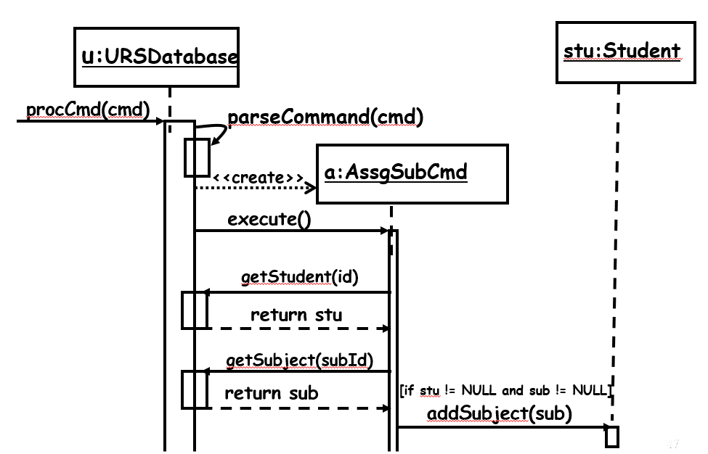

Ans:
class AssgSubCmd{
private URSDatabase u;
public execute(){
Student stu = u.getStudent(id);
Subject sub = u.getSubject(subId);
if (stu != null && sub != null)
stu.addSubject(sub);
}
}

- Develop a UML use case diagram for a software to be developed to help a small motor parts shop to automate its activities. The shop owner has informally described the requirements for the software as given in the following. [10]
The motor parts shop deals with a large number of motor parts for various vehicle types and manufactured by various OEMs (Original Equipment Manufacturers). Some of the motor parts are very small and some are of reasonably large size. The different parts are kept in wall mounted and numbered racks. Inspired by the just-in-time (JIT) philosophy, it is desired that as few inventory for each item as possible need to be maintained to reduce inventory overheads. Thus, one important problem that is being faced is to be able to automatically order items as soon as the number of items in the inventory reduces below a threshold value. The shop owner wants to maintain parts to be able to sustain selling for about one week. To calculate the threshold value for each item, the software must be able to calculate the average number of parts sold over the last one year for each part. At the end of each day, the shop manager would request the computer to generate the items to be ordered. The computer should lodge an indent on the vendor’s website by indicating on the on-line forms details such as part number, the amount required and the address of the vendor supplying the part. Using this system, the manager should be able to carry out a sell transaction that generates a cash memo. During the sales transaction, the manager may need to look up the location of the motor part being sold.
Ans:

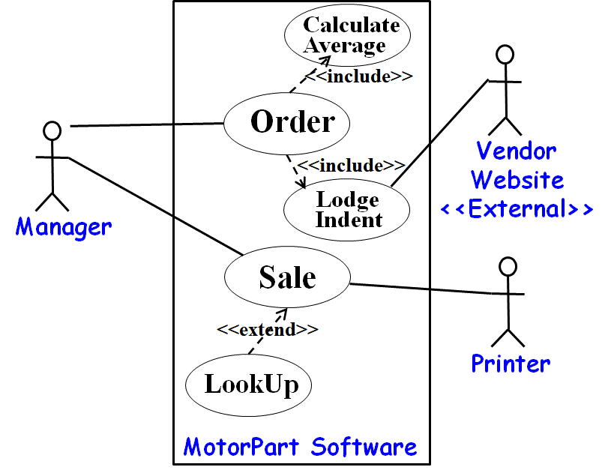

- An e-commerce company proposes to provide a mobile app-based item ordering scheme to its customers. The business process for this app-based item ordering scheme is briefly described in the following. Represent this planned business process (activities of the customer and that occurring at the e-commerce company) in an activity diagram. . [10]
The customer can use his mobile app to place an order. The mobile app will then create a corresponding order on the server of the e-comm company. Once the order has been created, the server will generate an invoice and e-mail it to the customer and also to the warehouse manager who operates the warehouse located at a remote site. The customer after receiving the invoice will pay the amount through an UPI transaction on the mobile app. In the meanwhile, the warehouse manager would pack the ordered items and send the packet to the shipping clerk. Once payment is received, the server will reconcile it against the invoice and send a payment confirmation message to the shipping clerk. The shipping clerk would ship the packet after he has received the packet from the warehouse manager and also has received the payment confirmation mail from the server.
Ans:
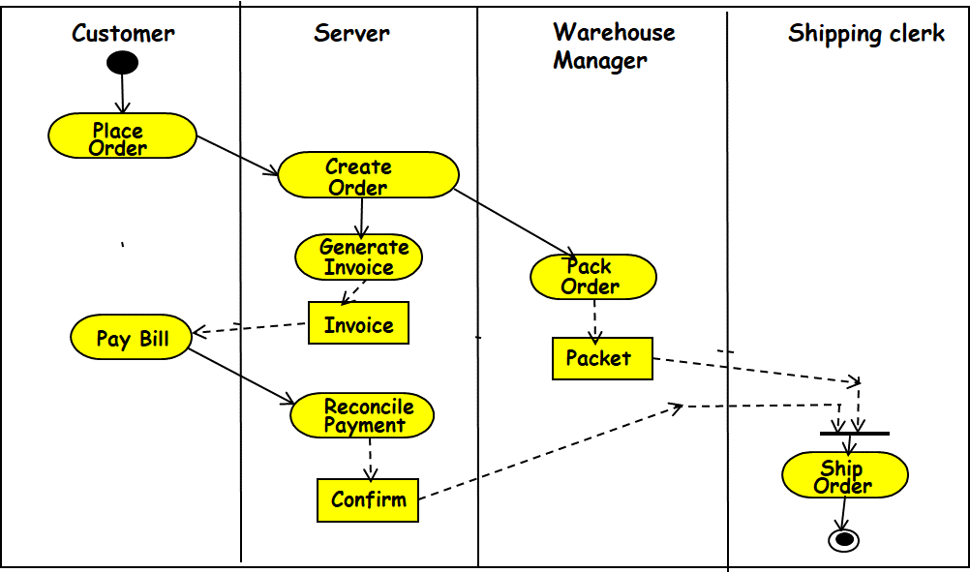
- Develop a UML class model of the following problem: . [20]
An airline owns 20 planes. These planes are of three types: Boeing 737, Boeing 777, and Airbus 330. Each plane of the airline operates some flights in India. India has several cities. Each airport is located in some city. A city may have multiple airports. Each flight has a source airport and a destination airport. A passenger can book one or more tickets on a flight for a certain date. The ticket has details such as booking reference number, PNR number, fare paid, and the code for the snack booked, if any. The airline has several employees. Some of the employees are ground staff and the others are crew members. Each flight is assigned a set of crew members.
Ans:
